Lexis Advance® Quicklaw®

advancing what’s possible

Tip Sheet | Link to this Page: Using Permalinks

The Link to This Page features enables you to generate a permanent hyperlink to the Lexis Advance Quicklaw page you are viewing. You can copy the hyperlink and paste it into a document, email message, or other similar item. Later, you can open the document, email message, or other item and select the hyperlink to display the Lexis Advance Quicklaw page. When generating permanent hyperlinks, keep the following points in mind:
- The link will expire after two years if not used.
- If sharing the link with others, they will need a subscription to the source(s) the link directs them to.
- If you generate a link to a list of results, the link will retrieve only the documents available at the time it was created.

Click on the link below to download a spreadsheet of Deep Links for all sources available on Lexis Advance® Quicklaw®. Note that the Deep Links in the spreadsheet do not expire unless the title is retired.
https://www.lexisnexis.ca/documents/xls/Deeplinks-for-Lexis-Advance-Quicklaw-Sources.xls

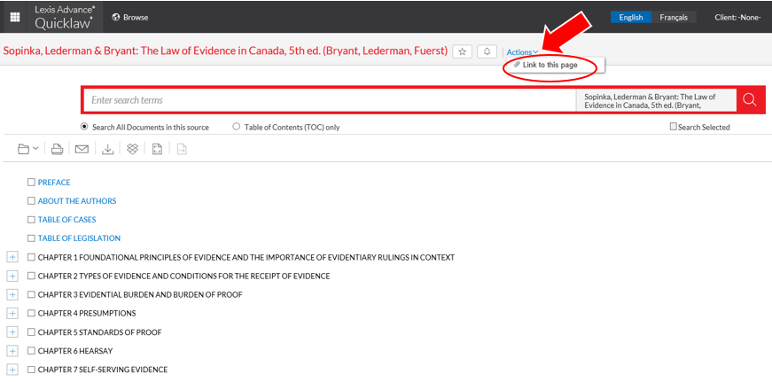
- To copy the link to your computer's clipboard, click on the Actions button, then select Link to this page.

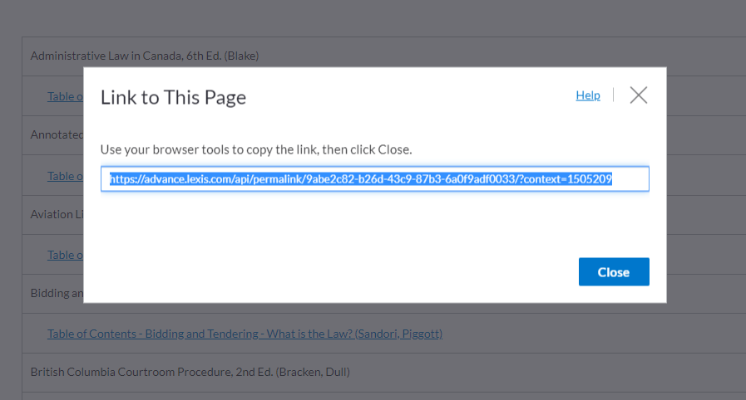
- Lexis Advance® Quicklaw® will generate a URL for the specific source. A pop-up box containing the link appears on the screen.

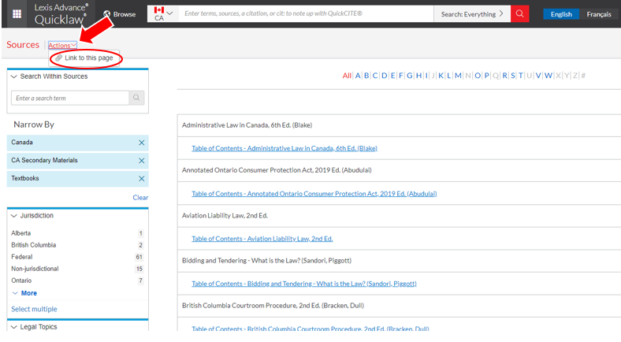
- Highlight the link, then use your browser commands to copy the link.

- Open a document or an email (or any similar item) where you would like to paste the link. Use your device commands to paste the link into the document. It is necessary to paste and store the link for it to work.

- Click Close to exit from this window.

